Name: AKHIL C
Roll no: 24BAD007
EXPT NO:8 | FORECASTING AND PREDICTIVE ANALYTICS USING TABLEAU  AND POWER BI
DATE: 14.08.2026

PRE-LAB QUESTIONS

- What is forecasting in the context of Business Intelligence (BI)?
Forecasting is the process of predicting future business trends or outcomes using historical data and statistical methods.

- Explain the difference between predictive analytics and descriptive analytics.
Descriptive analytics explains what happened in the past, while predictive analytics estimates what is likely to happen in the future.

- Name two common forecasting methods used in Tableau and Power BI.
- Time-series forecasting
- Moving average

- Why is data granularity important for accurate forecasting?
Proper data granularity ensures that data is available at the right level, such as daily or monthly, helping the forecasting model identify trends accurately.

- Name two challenges in forecasting using multiple data sources.
- Different data formats or structures
- Mismatched data granularity or inconsistent values between sources

IN-LAB EXERCISE:
OBJECTIVE:
To perform time series forecasting and predictive analytics on historical sales data using Tableau and Power BI, and visualize future trends for informed decision-making. PROCEDURE:
- Data Collection:
  - Import historical sales data from multiple sources:
    - Dataset 1: Sales Data (CSV) → Order ID, Order Date, Region, Sales Amount
    - Dataset 2: Promotions Data (Excel) → Promotion ID, Region, Promotion Start Date, Promotion End Date, Discount
- Data Preparation and Transformation:
  - Clean data: standardize date formats, remove duplicates, handle missing values.
  - Aggregate sales data at the required granularity (daily, weekly, or monthly).
  - Ensure numeric fields (Sales, Discount) are correct.
- Data Integration and Modeling:
  - Tableau: Connect datasets and relate them using the Region field.
  - Power BI: Create relationships in the Model view; define cardinality where necessary.
- Forecasting and Predictive Analytics:
  - Tableau:
    - Use the Forecast feature on Sales over time. o Apply trend models like Exponential Smoothing and visualize prediction intervals.
  - Power BI:
    - Use built-in forecasting in line charts. o Optionally, create a DAX measure for predicted sales using moving averages or linear regression.
- Create Calculated Fields:
  - Forecasted Sales = Predicted value from the model
  - Sales Growth % = ((Forecasted Sales – Actual Sales) / Actual Sales) * 100
- Design a Comprehensive Dashboard:
  - Line chart showing actual vs. forecasted sales over time.
  - KPI cards: Total Forecasted Sales, Expected Growth %.
  - Use combo charts to show sales trends along with promotion periods.
  - Highlight regions with expected growth above or below target thresholds.
- Validate Forecast Accuracy:
  - Compare forecasts against actual historical sales (back-testing).
  - Adjust forecasting parameters if necessary (e.g., seasonality length, smoothing factor).
- Publishing and Sharing:
  - Tableau: Publish workbook to Tableau Public or Tableau Server.
  - Power BI: Publish report to Power BI Service and share with stakeholders.

PowerBI Screenshots :
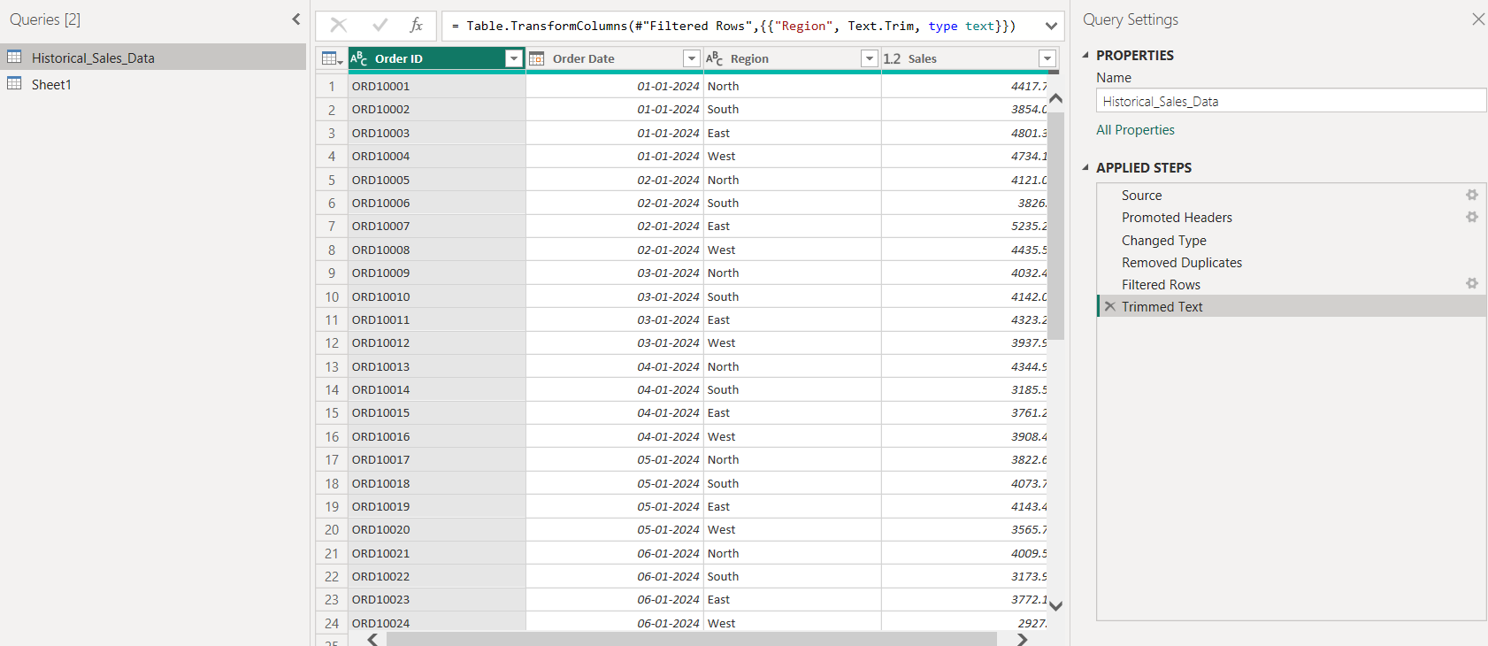
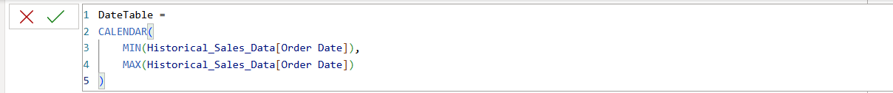
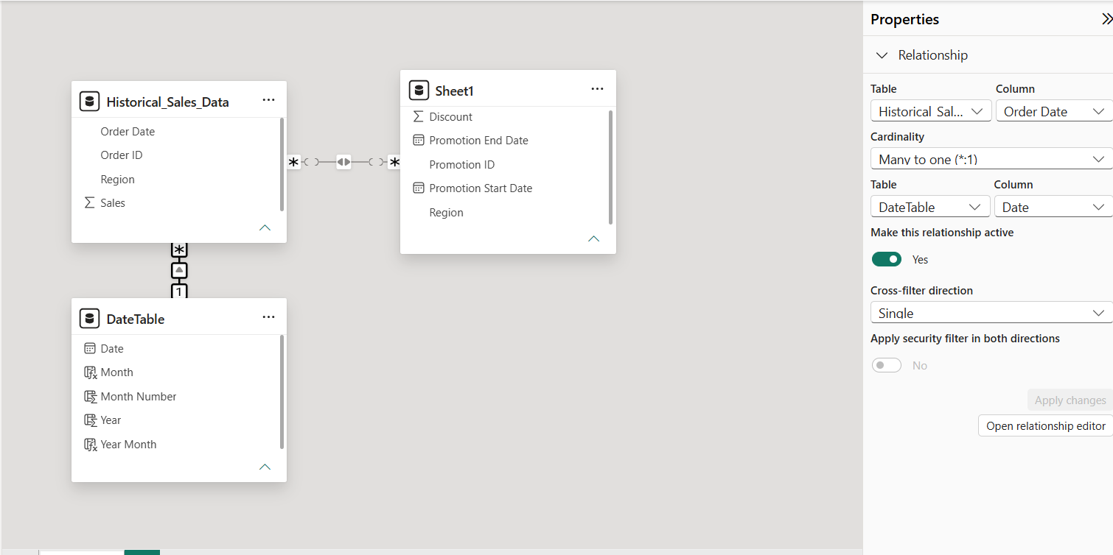
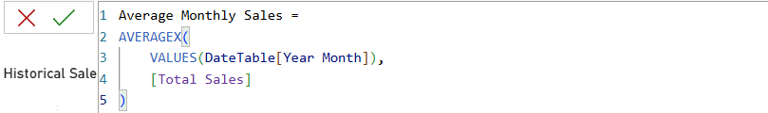
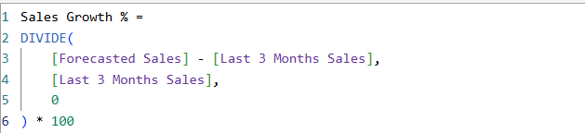
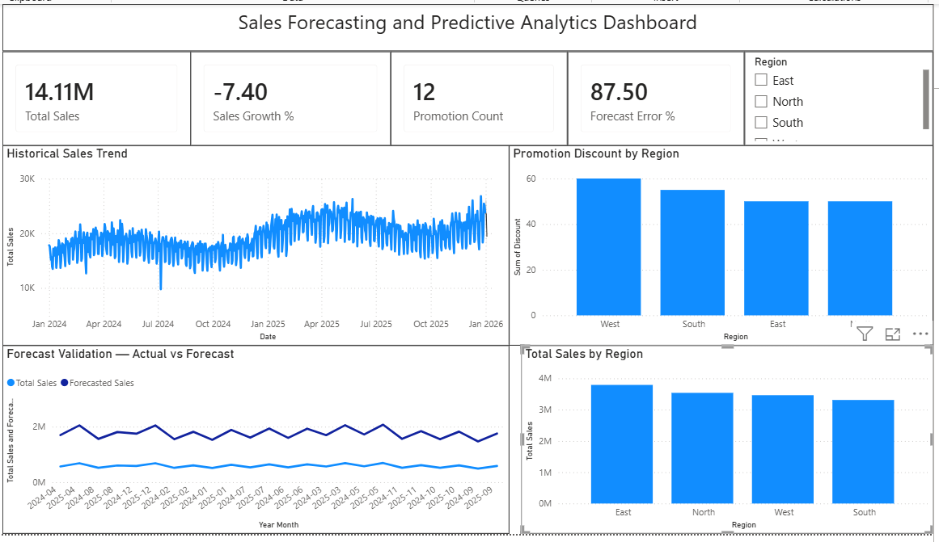

Tableau Screenshots :
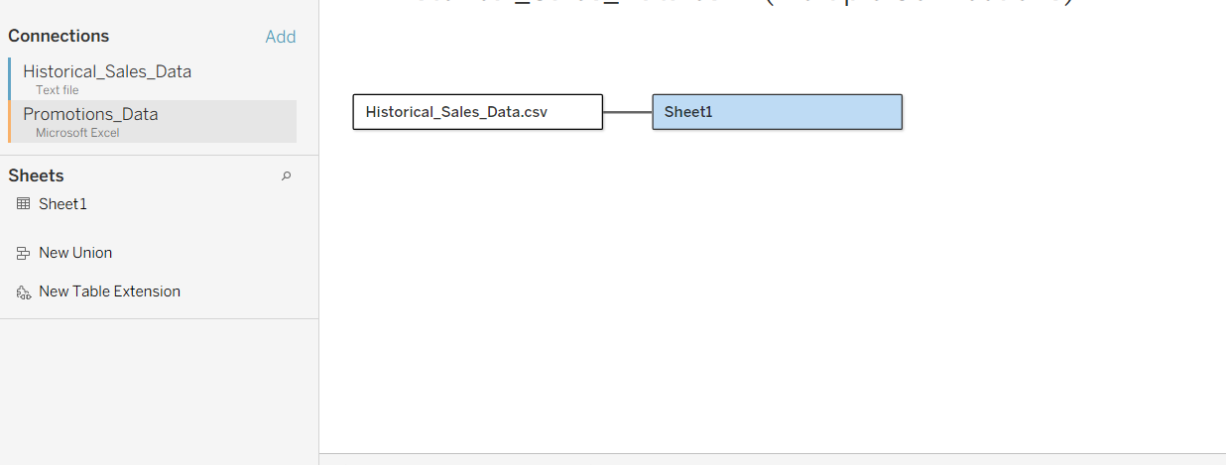
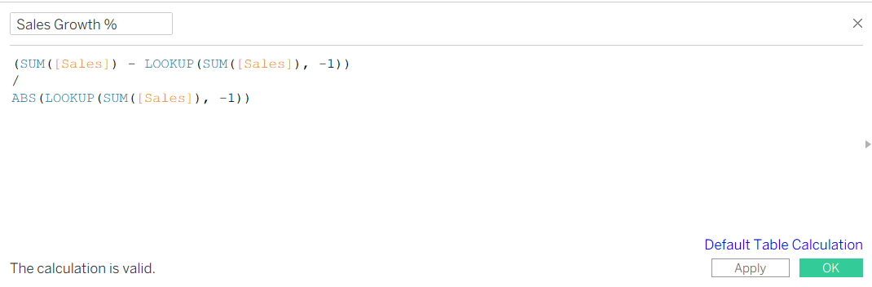
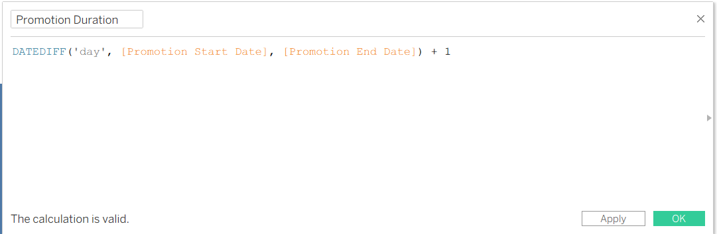
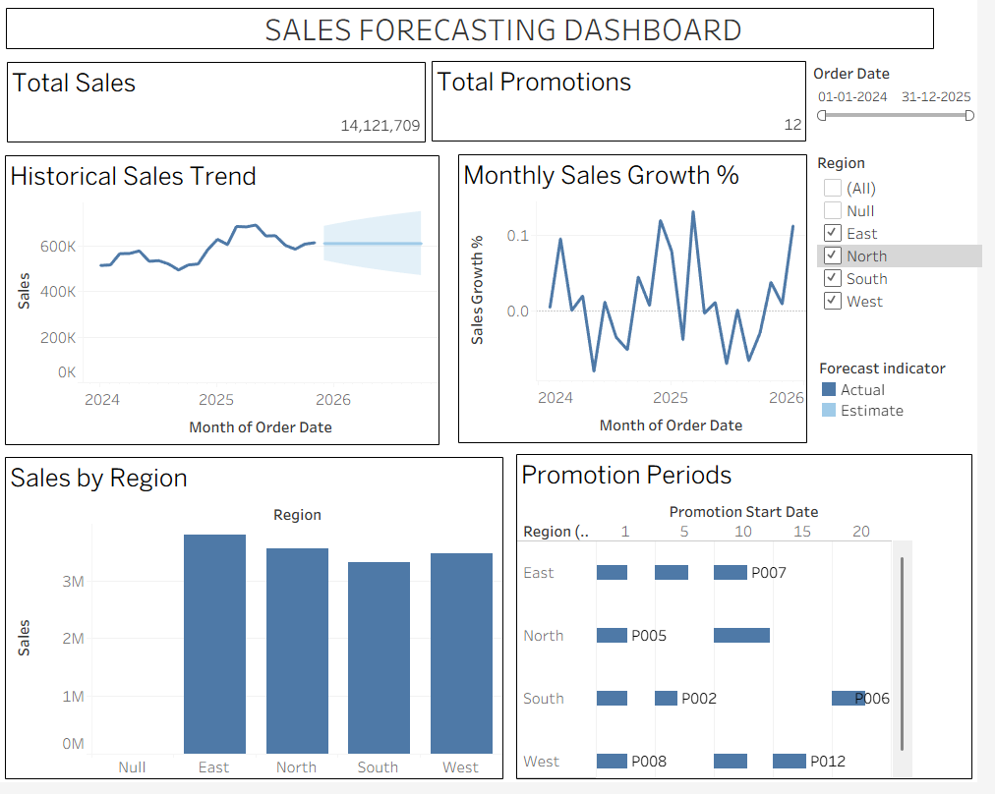

Experiment Datasets:
  - Dataset 1: Historical Sales Data (CSV) → Order ID, Order Date, Region, Sales
  - Dataset 2: Promotions Data (Excel) → Promotion ID, Region, Promotion Start/End Date, Discount

POST-LAB QUESTIONS
- How did forecasting help in predicting future sales trends for business planning?
Forecasting helped estimate future sales trends, allowing businesses to plan inventory, budgets, and resources more effectively.

- What forecasting method did you use, and why was it suitable for the dataset?
We used Exponential Smoothing in Tableau. It was suitable because the dataset contains sales values over regular time intervals and shows trends over time.

- What challenges, if any, did you face regarding missing data or irregular time intervals?
There were some missing sales and region values and duplicate records. These were removed during data cleaning. The sales data had regular daily time intervals, so there was no major issue with irregular intervals.

- How can predictive analytics influence decision-making in a retail environment?
It helps retailers predict demand, manage inventory, plan promotions, optimize pricing, and make better sales decisions.

- What additional data (e.g., competitor pricing, economic indicators) could be integrated to improve forecast accuracy?
Competitor pricing, customer demand, economic indicators, holidays, weather conditions, advertising spending, and customer purchase behavior could improve forecast accuracy.

RESULT:
The historical sales and promotions datasets were successfully cleaned, integrated, and modeled in Tableau and Power BI. Forecasting techniques provided predicted sales trends, growth percentages, and region-wise performance expectations. The resulting dashboards allowed managers to visualize actual vs. forecasted sales, enabling better planning and datadriven decision-making.

ASSESSMENT

Description |  | Max Marks | Marks Awarded
Pre Lab Exercise |  | 5
In Lab Exercise |  | 10
Post Lab Exercise |  | 5
Viva |  | 10
 | Total | 30
 | Faculty Signature

